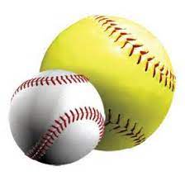
Becoming a High School Baseball/Softball Umpire
Any person who is 18 years of age or older and no longer in high school is eligible to apply for a Class 2 or Class 1 permit. (High School students may enroll in an OHSAA officiating class and obtain a Class 3 permit upon successful completion). Minimum age is 14 for a student to apply for an officiating class.
As a Class 1 umpire, you are eligible to officiate at all levels (varsity, junior varsity, freshman. Class 2 umpires are eligible to officiate all levels of contests except varsity contests. Class 3 umpires are restricted for freshman games.
Game fees vary depending upon the sport and game level. Varsity softball game fees are generally $56, whereas sub-varsity game fees are $51. For baseball, varsity game fees average about $65, whereas junior varsity and freshman games pay about $57 and $52, respectively.
To become a certified by the Ohio High School Athletic Association to umpire interscholastic baseball and softball games, individuals must first enroll in an officiating course. Locally, the class begins on January 19th and runs through February 13th. The class consists of 30 hours of instruction spread out over 11 meetings. Meetings will be held at Austintown High School and the Saxon Club. Normally, the cost of this class is $125 and includes the first-year umpire association dues. HOWEVER, the cost of this course for high school students is only $40!
To enroll in the local class, first go to the following web page to create your account and a profile: officials.myohsaa.org. Once registered, on the “Profile” page choose “Find a Course” from the list on the left-hand side. From the drop-down box, click choose “baseball” or “softball”, then click search. From the list generated, find the class taught by John Mang. Click on the button “View Course Details” to review important information. Finally, click on the button “Register for Class” and follow the subsequent instructions to enroll.
The class concludes with the officiating exam. Applicants must receive a passing score of 75% on the mechanics and rules exams to be a licensed OHSAA official. In addition, individuals must complete a course on concussion training and receive a permit number prior to officiating. Finally, all officials should join a local officials association. These and other details will be discussed during the course.
Once you receive your permit, you will be considered a Class 2 or 3 official and immediately eligible to be assigned games to work. How these assignments are made will be discussed during the officiating class.
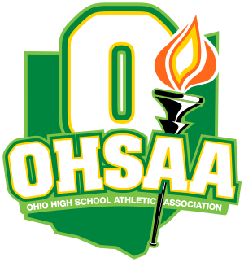
If you have further questions, please contact one of the following individuals:
John Mang (Lead Instructor and Assigner)
Tel./Text: 330.502.6665
email: mangtheref@gmail.com
Chet Cooper (Baseball Rules Interpreter)
Tel./Text: 330.518.3977
email: chet.cooper@me.com
Rich Randall (Softball Rules Interpreter)
Tel./Text: 330.717.2592
email: reddevil7588@yahoo.com

